**Hybrid Model using CAPM and Portfolio Optimization for Creating an Ideal Portfolio**

**Under the guidance of Professor, Dr. Abdullah Karasan, UMBC.**

**Goal :** This project aims to create a hybrid model that uses both CAPM analysis and Portfolio Optimization theory to build a portfolio that can potentially deliver highest gains with lowest possible risk.

**Programming Language & Tools used :** YFinance API, FRED API, Python.

**External Data Used:** CSV Containing list of all S&P500 stock names and respective sectors.

**Expected Insights** : Identify the most undervalued stocks in January 2020, and create an optimal portfolio by portfolio analysis.

**Research Question:** Both the theories have some common drawbacks due to assumptions and limitations and do not account for market volatility or external real world factor ? how will a portfolio created (in January 2020) by combination of CAPM and Portfolio optimization perform 3 years later (January 2023) after considering the impacts of the COVID-19 pandemic and recent market slowdown ?

**Phase-1 CAPM:**

* Considered the performance of all the 500 S&P 500 stocks over span of 2 years from 2018 to 2020.
* Identified some of the most undervalued and overvalued stocks in the market.
* Selected the most undervalued stocks from S&P500 in each major sector by comparison of the Beta coefficients.
* Overall the most overvalued stocks were : NVIDIA (1.94), AMD (1.9), Micron Technology (1.18), United Rentals (1.74), ON Semiconductor Corp (1.7) & Netflix (1.65)
* Overall the most undervalued stocks were: Newmont Corporation (0.20), American Electric Company (0.21), Duke Energy Corp (0.23), Southern Company (0.24), WEC Energy group (0.24).

**We then selected 12 most undervalued stocks form 12 sectors.**

These stocks, sectors and beta coefficients are listed below:

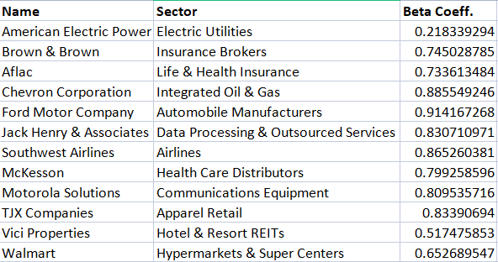

**Phase 2: Portfolio Optimization.**

* Then we carry out portfolio optimization for the 12 under-valued stocks selected in the previous step.
* The risk free rate is set to : 0.01.
* The stock weights for the ideal portfolio are given by:

([('AEP', 0.2292), ('AFL', 0.0), ('BRO', 0.29632), ('CVX', 0.0),

('F', 0.0), ('JKHY', 0.0), ('LUV', 0.0), ('MCK', 0.0),

('MSI', 0.26863), ('TJX', 0.20585), ('VICI', 0.0), ('WMT', 0.0)])

* Expected annual return: 24.9%
* Annual volatility: 12.9%
* Sharpe Ratio: 1.77

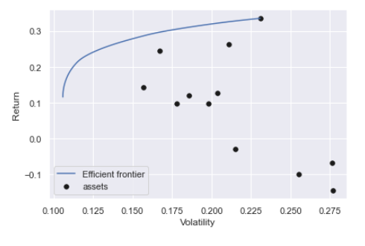

**Phase 3: Results:**

The 3 year growth of the 4 stocks of optimal portfolio are :

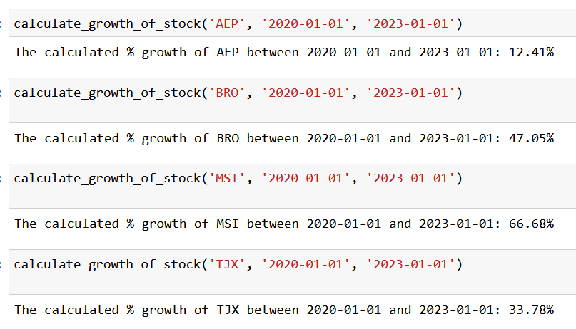

**Conclusion:**

The optimal portfolio of most undervalued stocks gave a real time return of 35% in the span of 3 years, even after the real world market conditions. (17.85% for S&P500)

